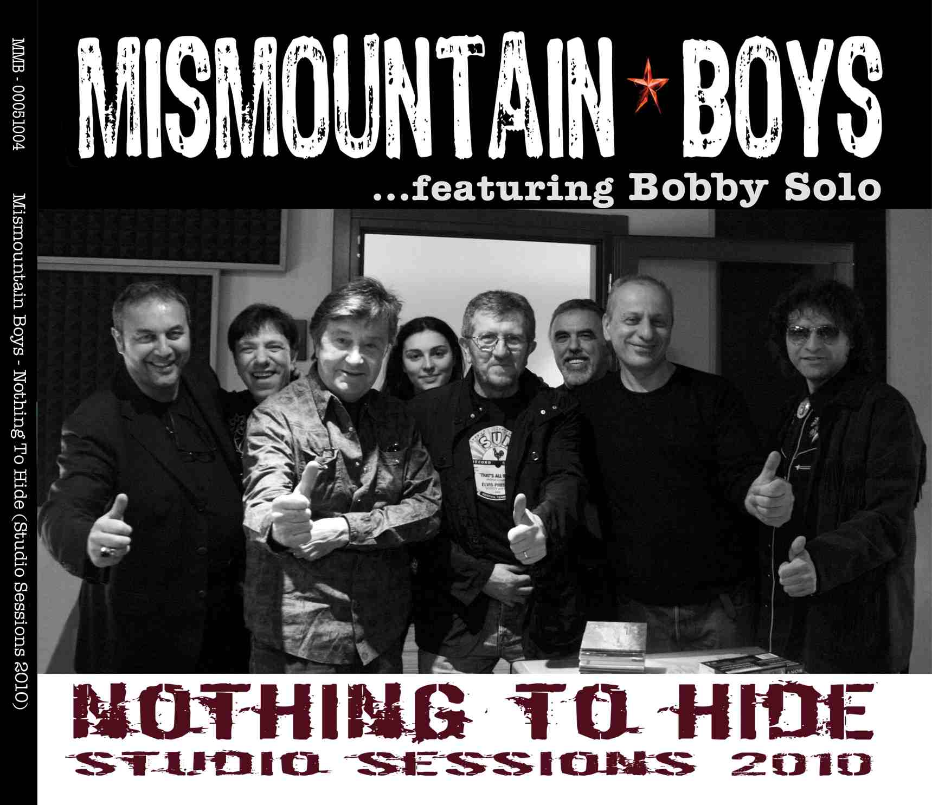

Don’t Think Twice It’s Allright
Well it ain't no use to sit and wonder why babe
If you don't know by now
And it ain't no use to sit and wonder why babe
It don't matter any how

When your rooster crows at the break of dawn
Look out your window and I'll be gone
You're the reason I'm travelling on
But don't think twice it's alright

And it ain't no use in turning on your light babe
That light I never knowed
And it ain't no use in turning on your light babe
I'm on the dark side of the road

I wish there was something you would do or say
To try and make me change my mind and stay
But we never did too much talking anyway
So don't think twice it's alright
And it ain't no use in calling out my name babe
Like you never did before
Ain't no use in calling out my name babe
I can't hear you any more

I'm thinking and a-wondering, walking down the road
I once loved a woman, a child I'm told
I gave her my heart but she wanted my soul
But don't think twice it's alright

I'm walking down that long lonesome road babe
Where I'm bound I can't tell
But goodbye is too good a word babe
So I'll just say fare thee well

I ain't saying you treated me unkind
You could have doen better but I don't mind
You just kinda wasted my precious time
But don't think twice it's alright

Ghost Riders In The Sky
An old cowboy went ridin' out one dark and windy day,
at bolder ridge he rested as he went along his way
when all at once a mighty herd of red eyed cows he saw
driving through the ragged skies… and up a cloudy draw.

Their brands were still on fire and their hooves were made of steel
their horns were black and shiny and their hot breath he could feel
a bolt of fear cut through him as they thundered through the sky
For he saw the riders coming hard... and he heard their mournful cry

Yipie i ay, Yipie i oh, …Ghost riders in the sky

Their face was drawn there eyes were blurred their shirts all soave with sweat
He's ridin' hard to catch that herd but he 'aint caught 'em yet
'cause they've all to ride forever on that range up in the sky
oh the horses start to shire as they ride on through they cry

Yipie i ay, Yipie i oh, …Ghost riders in the sky
Yipie i ay, Yipie i oh, …Ghost riders in the sky

LODI
Just about a year ago, I set out on the road
Seekin' my fame and fortune,
And lookin' for a pot of gold
Things got bad, and things got worse
I guess you know the tune

Oh, Lord, stuck in Lodi again

I rode in on a Greyhound, I'll be walkin' out if I go
I was just passin' through
Must be seven months or more
Ran out of time and money
Looks like they took my friends

Oh, Lord, stuck in Lodi again

The man from the magazine, Said I was on my way
Somewhere I lost connection
Ran out of songs to play
I came into town on a one-night stand
Looks like my plans fell through

Oh, Lord, stuck in Lodi again

If I only had a dollar, For every song I've sung
And every time I've had to play
While people sat there drunk
You know I'd catch the next train
Back to where I live

Oh, Lord, stuck in Lodi again
Oh, Lord, stuck in Lodi again

Lost On The River
Lost on the river, dark is the night
Just like the blind, prayin' for sight
Driftin' along,… heart filled with strife
I'm lost on the river, the river of life

Once dear I thought,… I knew the way
But that was before, ole sad yesterday
Words that you told me,… cut like a knife
I'm lost on the river, the river of life

Out on this river,… where sorrow creeps
Thinking of you, and how my heart weeps
Tomorrow you'll be… another man's wife
And I'm lost on the river, the river of life

And I'm lost on the river, the river of life
And I'm lost on the river,… the river of life

Big River
Now I taught the weeping willow how to cry
And I showed the clouds how to cover up a clear blue sky
And the tears that I cried for that woman are gonna flood you Big River
Then I'm gonna sit right here until I die
I met her accidentally in St.Paul, Minnesota
And it tore me up every time I heard her drawl southern drawl
Then I heard my dream was back downstream cavorting in Davenport
And I followed you Big River when you called
Then you took me to St. Louis later on down the river
A freighter said she's been here but she's gone boy she's gone
I found her trail in Memphis but she just walked up the block
She raised a few eyebrows and then she went on down alone
Now won't you batter down by Baton Rouge River Queen roll it on
Take that woman on down to New Orleans New Orleans
Go on I've had enough dump my blues down in the gulf
She loves you Big River more than me
Now I taught the weeping willow how to cry
And I showed the clouds how to cover up a clear blue sky
And the tears that I cried for that woman are gonna flood you Big River
Then I'm gonna sit right here until I die

Rocky Top
Wish that I was on ole Rocky Top down in the Tennessee hills
Ain't no smoggy smoke on Rocky Top ain't no telephone bills
Once I had a girl on Rocky Top half bear other half cat
Wild as a mink but sweet as soda pop I still dream about that

Rocky Top you'll always be home sweet home to me
Good ole Rocky Top,

…Rocky Top Tennessee, Rocky Top Tennessee

Once 2 strangers climbed ole Rocky Top looking for a moonshine still
Strangers ain't come down from Rocky Top reckon they never will
Corn don't grow at all on Rocky Top ground's too rocky by far
That's why all the folks on Rocky Top drink their corn from a jar

Rocky Top you'll always be home sweet home to me
Good ole Rocky Top,

…Rocky Top Tennessee, Rocky Top Tennessee

Rocky Top you'll always be home sweet home to me
Good ole Rocky Top,

…Rocky Top Tennessee, Rocky Top Tennessee

…Rocky Top Tennessee, Rocky Top Tennesse …e …e …e

Your Love Is Like A Flower
It was long long ago in the moonlight
We were sittin on the banks of the stream
When you whispered so sweetly, I love you
And the waters murmured a tune

Oh they tell me you love is like a flower
In the spring time blossom so fair
In the fall when it withers away dear
And they tell me that's the way of your love

I remember the night little darlin
We were talkin of days gone by
When you told me you always would love me
That your love for me would never die

Oh they tell me you love is like a flower
In the spring time blossom so fair
In the fall when it withers away dear
And they tell me that's the way of your love

It was spring when you whispered these words dear
The flowers were all bloomin so fair
But today as the snow falls around us
I can see that you love is not there

Oh they tell me you love is like a flower
In the spring time blossom so fair
In the fall when it withers away dear
And they tell me that's the way of your love
And they tell me that's the way of your love
And they tell me that's the way of your love

My Toot Toot
Don't mess with my toot toot,
don't mess with my toot toot,
Well you can have the other woman,
but don't mess with my toot toot.

She was born in her birth suit, the doctor slap her behind, (SLAP!)
Say you're gonna to be special, you sweet little toot toot.

Well you can look as much, but if you much as touch,
You're gonna have yourself a case - I'm gonna break your face!

Don't mess with my toot toot,
don't mess with my toot toot,
Well you can have the other woman,
but don't mess with my toot toot.

Don't mess with my toot toot,
don't mess with my toot toot,
Well you can have the other woman,
but don't mess with my toot toot.

Whoa, Mama was the same way too, all the fellas didn't know what to do,
And Papa never had a chance, with a sweet little toot toot.

She was born in her birth suit, the doctor slap her behind, (SLAP!)
Said you're gonna to be special, you sweet little toot toot.

Don't mess with my toot toot,
don't mess with my toot toot,
Well you can have the other woman,
but don't mess with my toot toot.

Blue Eyes Crying In The Rain
In the twilight glow I see her
Blue eyes crying in the rain

When we kissed goodbye and parted
I knew we'd never meet again

Love is like a dying ember
Only memories remain
Through the ages I remember
Blue eyes crying in the rain

Someday when we meet up yonder
We'll stroll hand in hand again
In a land that knows no parting
Blue eyes crying in the rain
Blue eyes crying in the rain

Blue Moon of Kentucky
Blue moon… blue moon
Blue moon… keep shining bright
Blue moon… keep on shining bright
You gonna bring me back my baby tonight
Blue moon… keep shining bright

Blue moon of Kentucky keep on shining
Shine on the one that's gone and proved untrue
Blue moon of Kentucky keep on shining
Shine on the one that's gone and left me blue

It was on a moonlight night the stars were shining bright
When they whispered from on high your love has said good-bye
I said, Blue moon of Kentucky keep on shining
Shine on the one that's gone and said good-bye

Blue moon… blue moon
Blue moon… keep shining bright
Blue moon… keep on shining bright
You gonna bring me back my baby tonight
Blue moon… keep shining bright

I said, Blue moon of Kentucky keep on shining
Shine on the one that's gone and proved untrue
Blue moon of Kentucky keep on shining
Shine on the one that's gone and left me blue

Shine on the one that's gone and left me blue
Shine on …….the one that's gone and left me…

Tennessee
You have heard and read about the state of Tennessee
Down in the southern state is where I want to be
Where the valleys are so green and the mountains are so tall
You will know just what I mean when you hear them say You all

Tennessee, (Tennessee)
I hear you calling me (I hear you calling me)
The home of Davy Crockett in the hills of Tennessee

When I was a little boy around the folks back home
My mother always said to me, Jimmy, please don't roam
Now that I have gone away my heart is full of woe
When I think of Mom and Dad, that's where I want to go

Tennessee, (Tennessee)
I hear you calling me (I hear you calling me)
The home of Davy Crockett in the hills of Tennessee

If ever I get back to that state of Tennessee
I tell you there'll be no more roaming for me
There lives a sweetheart who said she'd marry me
As soon as I get back to that state of Tennessee

Tennessee, (Tennessee)
I hear you calling me (I hear you calling me)

The home of Davy Crockett in the hills of Tennessee

Bonanza
The plain we hold is as good as gold, Bonanza
Hand in hand, we built this land, the Ponderosa Ranch
Our birthright is this Cartwright Bonanza
We here belong and stand in strong, wrong ain't got a chance

Day by day, work or play, ready side by side
Hello, friend! Come on in! The gate is open wide!
Bound to be a-fightin' free, Bonanza
Swinging pines of boundary lines for the
Ponderosa Ranch

Day by day, work or play, ready side by side
Hello, friend! Come on in! The gate is open wide!
Bound to be a-fightin' free, Bonanza
Swinging pines of boundary lines for the
Ponderosa Ranch

